# INTRODUCTION

* 1. Overview

Project name is Implementing CRM for result tracking of a candidate with internal marks. In this project we created objects (semester, candidates, course details, lecturer details, internal results), fields and relationship and candidate with internal card app. Next we created reports and dashboards.

* 1. Purpose

Through this program developed by us candidates can easily check the internal marks result in CRM platform along with their name and subject name. We can be achieved save the time using this.

# PROBLEM DEFINITION & DESIGN THINKING

* 1. Empathy Map

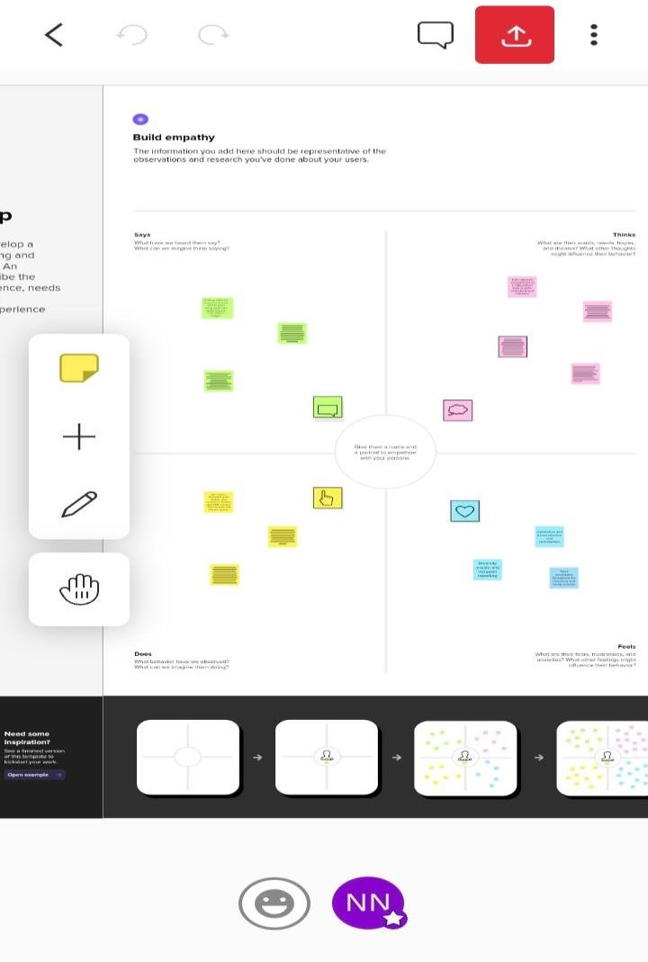

* 1. Ideation & Brainstorming Ma

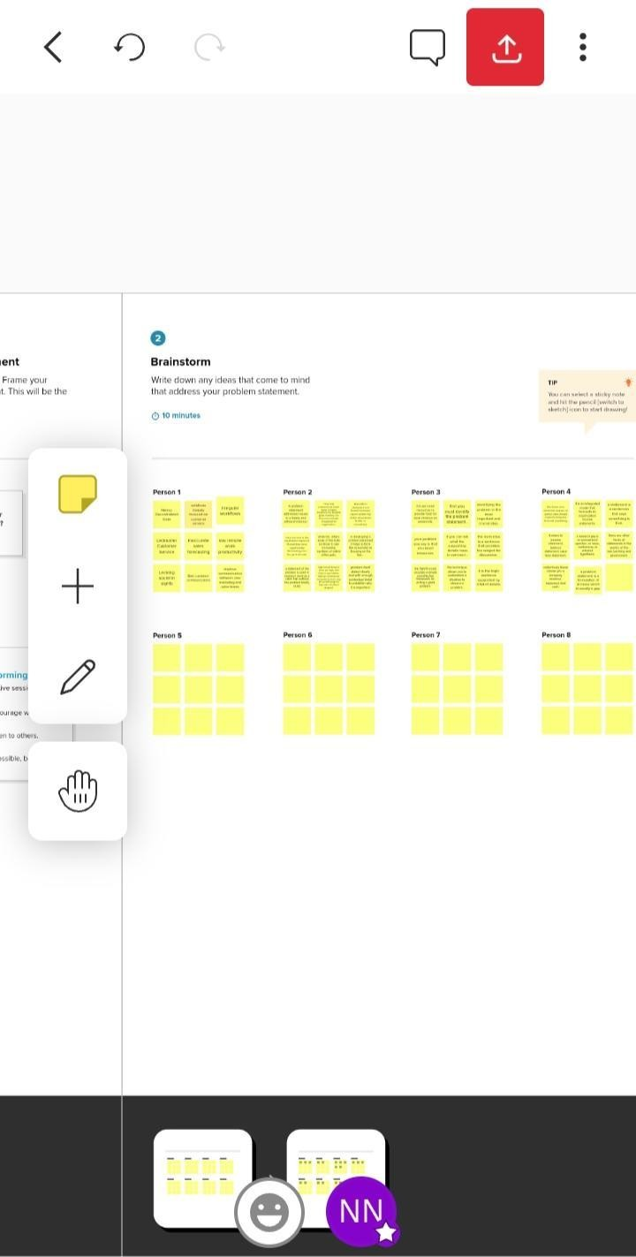

# RESULT

* 1. Data Model:

|  |  |  |  |  |  |  |  |  |  |  |
| --- | --- | --- | --- | --- | --- | --- | --- | --- | --- | --- |
| **Object name** | **Fields in the object** | | | | | | | | | |
| Semester |  | **Field lable** | | | | | | | **Data type** |  |
| Semester name | | | | | | | Text |  |
|  | | | | | | | | | |
| Candidate |  | **Field lable** | | | **Data type** | | |  | | |
| Candidate  name | | | Text | | |
| Candidate  id | | | Text | | |
| Semester  name | | | Text | | |
| Course details |  | **Field**  **lable** | **Data**  **type** | | |  | | | | |
| Course  name | Text | | |
| Course  id | Text | | |
| Lecturer details |  | **Field**  **lable** | | **Data**  **type** | | |  | | | |
| Lecturer  role | | Text | | |
| Lecturer  name | | Text | | |
| Course  id | | Text | | |
| Internal results |  | **Field**  **lable** | | | **Data**  **type** | | |  | | |
| Candidate  id | | | Text | | |
| Course id | | | Text | | |
| Marks | | | Text | | |

# Activity & screenshot

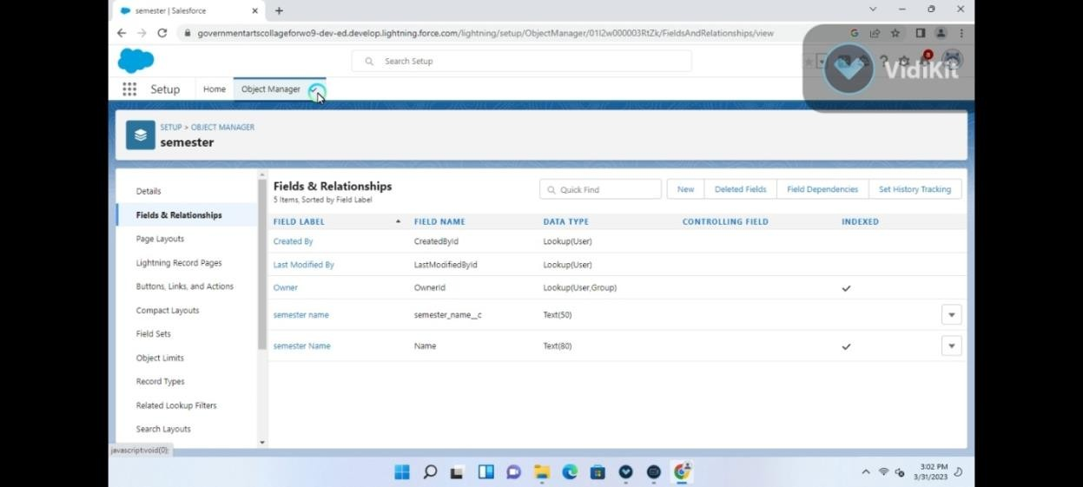

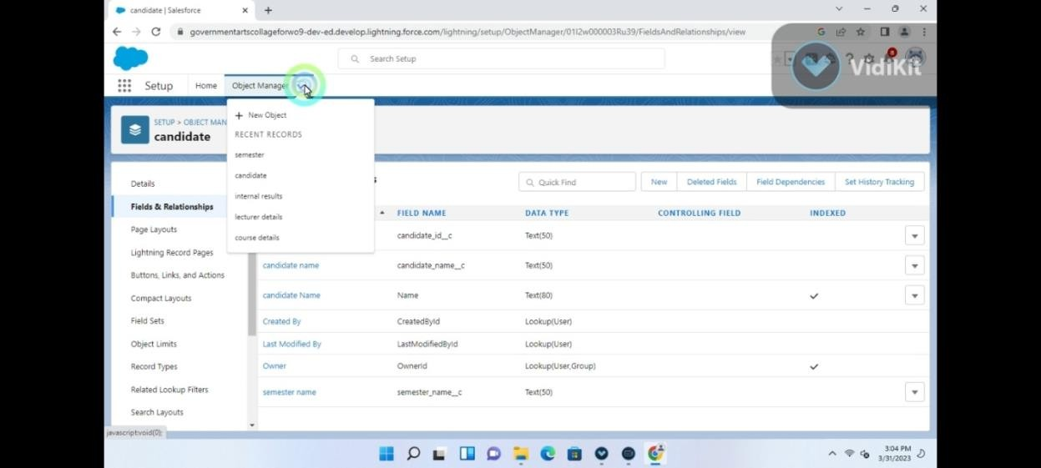

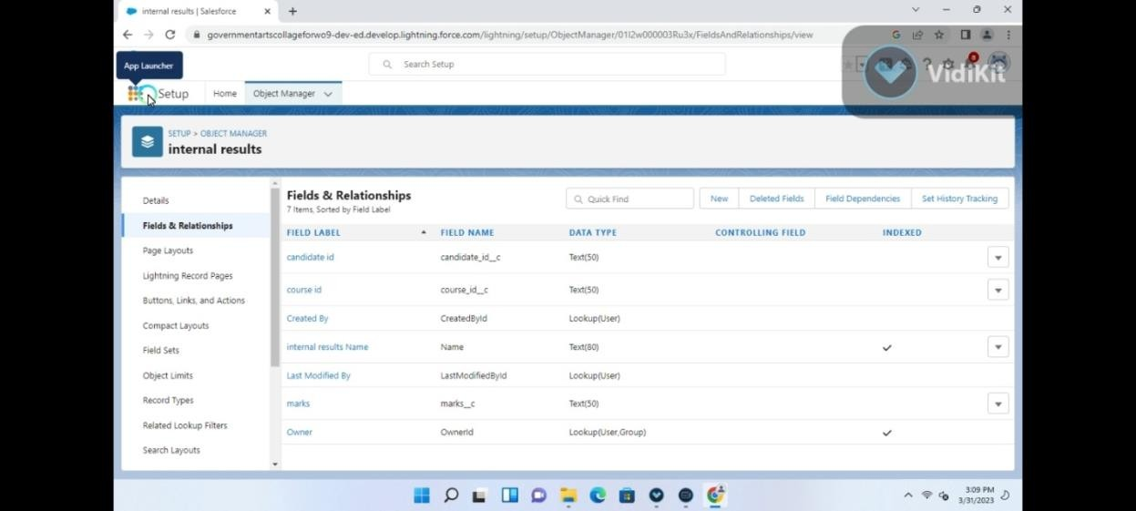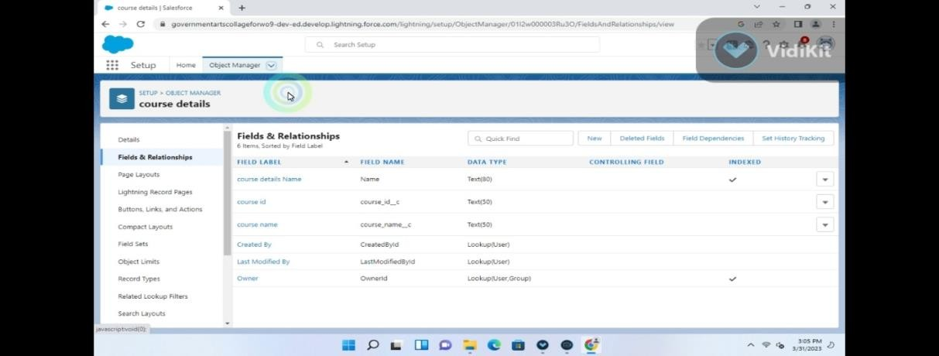

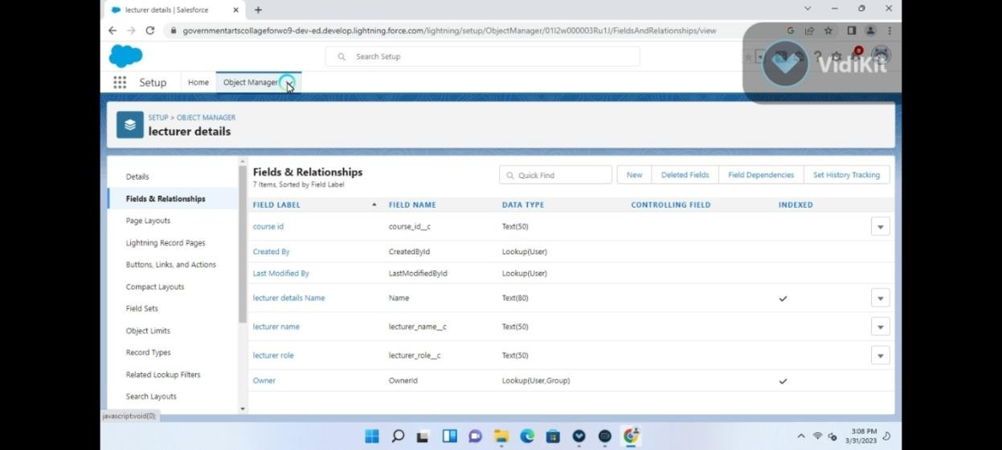

1. **Trailhead profile public URL**

**Team Leader -https://trailblazer.me/id/ppunitha3 Team Member 1 –https://trailblazer.me/id/rramya83**

**Team Member 2 –<http://trailblazer.me/id/>smuthuramalingam**

**Team Member 3 – https://trailblazer.me/id/skaleessnega**

# ADVANTAGES & DISADVANDAGES

* Trustworthy reporting
* Dashboards that visually showcase data
* Simplified collaboration
* Proactive service
* Poor communication
* Plan out integration needs in advance
* Cost
* Deployment type

# APPLICATIONS

This solution can be applied is used to release the exam results and to know the results and to know the results clearly.

# conclution

This contains information on prescreening, resume, employment preferences EEO

# Future

Posting jobs internally can enhance a company’s recruitment strategy, can provide career development opportunities for employees and can be positive communication.